**DOZY DRIVING DETECTION SYSTEM**

*A*

*Mini Project Report*

*Submitted in partial fulfilment of the*

*Requirements for the award of the Degree of*

**BACHELOR OF ENGINEERING**

IN

**INFORMATION TECHNOLOGY**

By

**M. SUSHMA - 1602-19-737-117**

**G. SUMA SRI - 1602-19-737-116**

**C. SRILATHA - 1602-19-737-113**



**Department of Information Technology**

**Vasavi College of Engineering (Autonomous)**

**(Affiliated to Osmania University)**

**Ibrahimbagh, Hyderabad-31**

**2021**

**Vasavi College of Engineering (Autonomous)**

**(Affiliated to Osmania University)**

**Hyderabad-500 031**

**Department of Information Technology**



**DECLARATION BY THE CANDIDATE**

We, **M. SUSHMA, G. SUMA SRI, C. SRILATHA** bearing hall ticket numbers, **1602-19-737-117, 1602-19-737-116, 1602-19-737-113**, hereby declare that the project report entitled **“DOZY DRIVING DETECTION SYSTEM”** Department of Information Technology, Vasavi College of Engineering, Hyderabad, is submitted in partial fulfilment of the requirement for the award of the degree of **Bachelor of Engineering** in **Information Technology**

This is a record of bonafide work carried out by me and the results embodied in this project report have not been submitted to any other university or institute for the award of any other degree or diploma.

**M. SUSHMA**

**1602-19-737-117**

**G. SUMA SRI**

**1602-19-737-116**

**C. SRILATHA**

**1602-19-737-113**

(Faculty In-Charge) (Head,Dept of IT)

MINI PROJECT

ON

DOZY DRIVING DETECTION SYSTEM

TEAM MEMBERS GUIDES

M. Sushma(1602-19-737-117) Dr.B. Kezia Rani

G. Suma Sri(1602-19-737-116) Haseeba Yaseen

C. Srilatha(1602-19-737-113) Mukesh Kumar Tripathi

**BONAFIDE CERTIFICATE**

This is to certify that this project titled ‘**DOZY DRIVING DETECTION SYSTEM**’ is a project work of a team of three members Ms. M. Sushma(1602-19-737-117), Ms. G. Suma Sri(1602-19-737-116) and Ms. C. Srilatha(1602-19-737-113) who carried out this project under supervision in the V semester for the academic year 2021-2022.

Signature Signature

Internal Examiner External Examiner

**ACKNOWLEDGEMENT**

A project is never the outcome of a single person’s effort. It is a confluence of varied though processes harmoniously integrated into a resourceful product.

I owe immense thanks to my project Guide Mrs .Dr .KEZIA RANI, Assistant Professor, Dr .HASEEBA YASEEN, Assistant Professor, Mr. MUKESH KUMAR TRIPATHI , Assistant Professor Department Of Information Technology, Vasavi College Of Engineering for this sustained interest, constructive criticism and constant encouragement at every stage of this Endeavour.

Also, I whole heartedly thank Dr.T.Ramamohan Rao, Professor and Head Of Department, Vasavi College Of Engineering for his constant encouragement.

I extended my deep sense of gratitude to the Principal Dr.S.V.Ramana and the management of Vasavi College Of Engineering for providing of the best amenities to enable us to complete my project in stipulated time.

List of Tables:

1. Abstract…………………………………………..09
2. Introduction………………………………………10
3. Purpose……………………………………...10
4. Problem Definition………………………….11
5. Project Scope………………………………..11
6. Project Features……………………………..11
7. Related Work……………………………………..13
8. Literature Survey……………………………13
9. Proposed System…………………………….13
10. Proposed Work……………………………………15
11. Use Cases……………………………………….15
12. Hardware Specifications………………………..16
13. Architecture and Technology used……………..17
14. Design…………………………………………..18
15. UML Component Diagram………………..18
16. UML Sequence Diagram………………….19
17. UML Flow Chart………………………….19
18. Implementation…………………………………20
19. Modules……………………………………20
20. Algorithm………………………………….21
21. Github Folder………………………………23
22. Testing…………………………………………24
23. Results…………………………………………….26
24. Conclusion………………………………………...28
25. Discussion and Future Work……………………...29
26. References…………………………………………30

**ABSTRACT**

Nowadays, more and more professions require long-term concentration. Drivers must keep a close eye on the road, so they can react to sudden events immediately. Driver fatigue often becomes a direct cause of many traffic accidents. Therefore, there is a need to develop the systems that will detect and notify a driver of her/him bad psychophysical condition, which could significantly reduce the number of fatigue-related car accidents. However, the development of such systems encounters many difficulties related to fast and proper recognition of a driver’s fatigue symptoms. One of the technical possibilities to implement dozy driver detection systems is to use the vision-based approach. The technical aspects of using the vision system to detect a driver drowsiness are also discussed. Drowsiness and Fatigue of drivers are amongst the significant causes of road accidents. Every year, they increase the amounts of deaths and fatalities injuries globally. This system deals with automatic driver drowsiness detection based on visual information. We propose an algorithm to locate, track, and analyze the drivers face and a scientifically supported measure of drowsiness associated with slow eye closure.

**INTRODUCTION**

* 1. PURPOSE

In recent years, the rise of accident fatalities has grown significantly around the world. Drowsy driving is a controversial topic when coming to road safety. Nearly everyone who drives a car on a regular basis already experienced drowsiness or even micro-sleeps during driving. The objective of the proposed work is to study and improve the supervised learning algorithms to predict the stock price.

Neglecting our duties towards safer travel has enabled hundreds of thousands of tragedies to get associated with this wonderful invention every year. It may seem like a trivial thing to most folks but following rules and regulations on the road is of utmost importance. While on road, an automobile wields the most power and in irresponsible hands, it can be destructive and sometimes, that carelessness can harm lives even of the people on the road. One kind of carelessness is not admitting when we are too tired to drive. In order to monitor and prevent a destructive outcome from such negligence, many researchers have written research papers on driver drowsiness detection systems. But at times, some of the points and observations made by the system are not accurate enough. Hence, to provide data and another perspective on the problem at hand, in order to improve their implementations and to further optimize the solution, this project has been done.

* 1. PROBLEM DEFINITION

Drowsy Driving is a deadly combination of driving and sleepiness. The number of road accidents due to Drowsy Driving is increasing at an alarming rate worldwide. Not having a proper sleep is the main reason behind drowsiness while driving. However, other reasons like sleep disorders, medication, alcohol consumption, or driving during night shifts can also cause drowsiness while driving. According to are port of AIIMS Neurology India —Sleep Disorders became the reason behind around more than 20% of all road accidents and around 23% of truck drivers have sleep deprivations. Whatever be the reason for drowsiness, the fatalities due to drowsy driving are increasing every year.

* 1. PROJECT SCOPE

There are many products out there that provide the measure of fatigue level in the drivers which are implemented in many vehicles. The driver drowsiness detection system provides the similar functionality but with better results and additional benefits. Also, it alerts the user on reaching a certain saturation point of the drowsiness measure.

* 1. PROJECT FEATURES

Machine learning is Associate in drowsiness detection of computer science (AI) that gives systems the flexibility to mechanically learn and improve from expertise while not being expressively programmed. Driver drowsiness their time requirement is a fraction of the previously used methods. By normalizing the distance and position of the reference points, all faces should be transformed into the same size and position. For normalization, eyes serve as points of reference. Other OpenCV algorithm finds the eyes on any grayscale image by searching characteristic features of the eyes and eye sockets. Tests made on a standard database show that the algorithm works very fast and it is reliable. Here we will work with face detection. Then we need to extract features from it. For this, OpenCV features shown in the below image are used. They are just like our convolutional kernel.

**RELATED WORK:**

2.1 LITERATURE SURVEY

This survey is done to comprehend the need and prerequisite of the general population, and to do as such, we went through different sites and applications and looked for the fundamental data. Based on these data, we made an audit that helped us get new thoughts and make different arrangements for our task. We reached the decision that there is a need of such application and felt that there is a decent extent of progress in this field too.

* 1. PROPOSED SYSTEMS

In this project a novel approach to critical parts of face detection problems is given, based on analogic cellular neural network (OpenCV) algorithms. The proposed OpenCV algorithms find and help to normalize human faces is, effectively while cause for most accident related to the vehicles crashes. Driver fatigue their time requirement is a fraction of the previously used methods. For normalization, eyes serve as point reference. Other OpenCV algorithm finds the eyes on any grayscale image by searching characteristic is features of the eyes and eye sockets. Tests made on a standard database show that the algorithm works very fast and it is reliable. In proposed method, first the video is acquired by the webcam for processing. The video of the driver is captured from the camera which is installed in front of the driver on the car dashboard. It will be passed to pre processing which prepares the image for further processing by the system. When the eyes are closed for more than few seconds then it is deducible that the driver is feeling drowsy. Hence drowsiness is detected and an alarm sounded. After that the whole process is repeated as long as the driver is driving the car.

**PROPOSED WORK**

1. **USE CASES:**

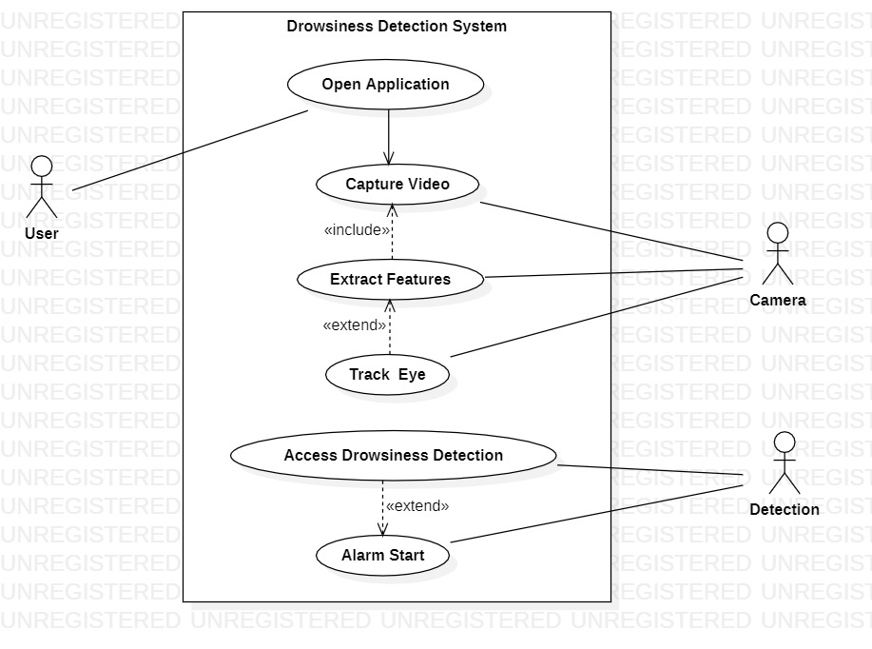

**b) HARDWARE SPECIFICATIONS:**

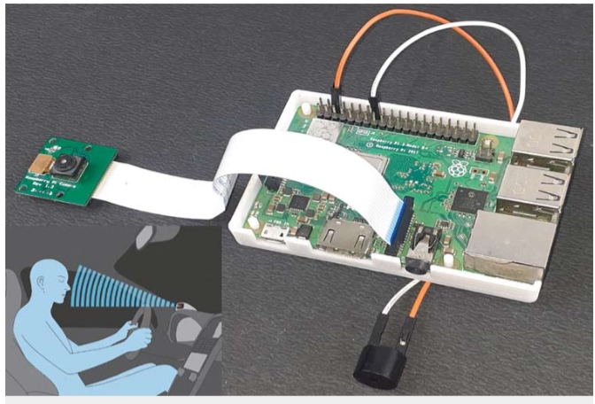**c) ARCHITECTURE:**

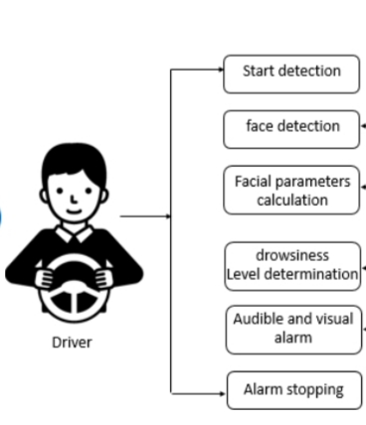

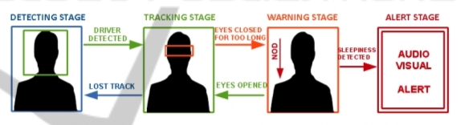

**TECHNOLOGY USED:**

**Machine learning**:

Machine learning is the kind of programming which gives computers the capability to automatically learn from data without being explicitly programmed. This means in other words that these programs change their behaviour by learning from data. Python is clearly one of the best languages for machine learning. Python does contain special libraries for machine learning namely opencv, tkinter and numpy which great for linear algebra and getting to know kernel methods of machine learning. The language is great to use when working with machine learning algorithms and has easy syntax relatively.

**PYCHARM:**

Python has a voluminous arrangement of inbuilt libraries that can be utilized. Not many of them are:

1. NumPy
2. Tkinter
3. Pygame
4. Opencv-python

**DESIGN:**

**UML Static Diagrams:**

COMPONENT DIAGRAM:

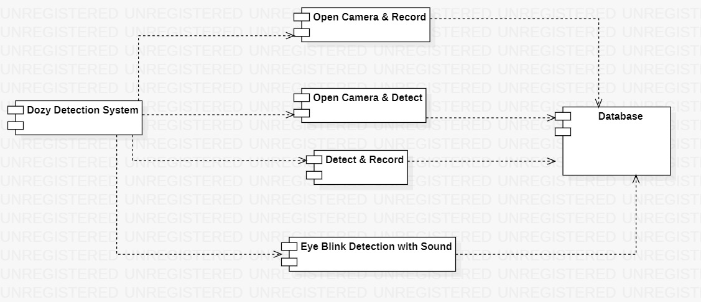

**UML Run Time Diagrams:**

SEQUENCE DIAGRAM:

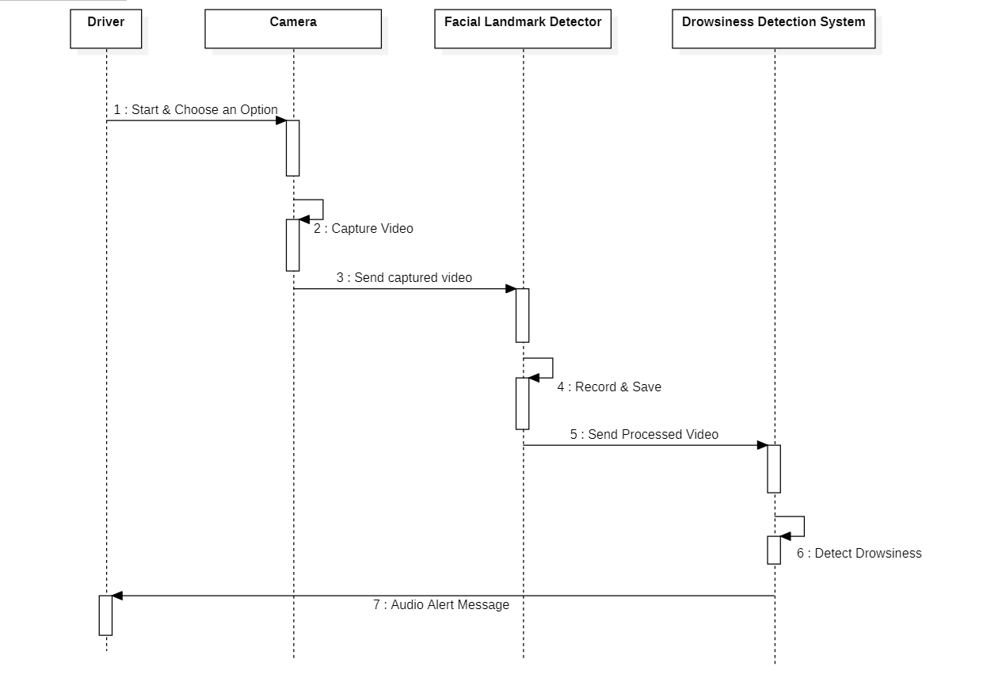FLOW CHART:

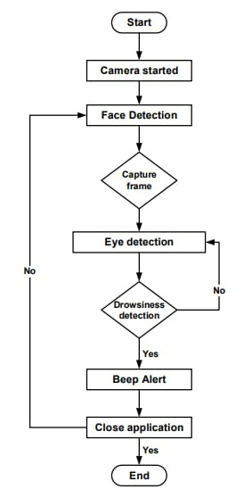

**IMPLEMENTATION:**

**a) Modules**

**OpenCV**:

OpenCV stands for Open Source Computer Vision. It's an Open Source BSD licensed library that includes hundreds of advanced Computer Vision algorithms that are optimized to use hardware acceleration. OpenCV is commonly used for machine learning, video processing and much more. OpenCV has a modular structure. There are shared and static libraries and a CV Namespace. In short, OpenCV is used in our application to easily load bitmap files that contain landscaping pictures and perform a blend operation from videos captured through webcam.

**TKINTER:**

Tkinter is a standard Python interface to the Tk GUI toolkit shipped with Python. Python with tkinter is the fastest and easiest way to create the GUI applications.

**PYGAME**:

Pygame is a cross-platform set of Python modules which consists of computer graphics and sound libraries designed to be used with the Python.

b) **Algorithm**

def blink():

capture =cv2.VideoCapture(0)

face_cascade=cv2.CascadeClassifier('lbpcascade_frontalface.xml')

eye_cascade = cv2.CascadeClassifier('haarcascade_eye.xml')

blink_cascade=cv2.CascadeClassifier('CustomBlinkCascade.xml')

while True:

ret, frame = capture.read()

gray = cv2.cvtColor(frame,cv2.COLOR_BGR2GRAY)

faces = face_cascade.detectMultiScale(gray)

for (x,y,w,h) in faces:

font = cv2.FONT_HERSHEY_COMPLEX cv2.putText(frame,'Face',(x+w,y+h),font,1,(250,250,250),2,cv2.LINE_AA) cv2.rectangle(frame,(x,y),(x+w,y+h),(255,0,0),2)

roi_gray = gray[y:y+h, x:x+w]

roi_color = frame[y:y+h, x:x+w]

eyes = eye_cascade.detectMultiScale(roi_gray)

for(ex,ey,ew,eh) in eyes:

cv2.rectangle(roi_color,(ex,ey),(ex+ew,ey+eh),(0,255,0),2)

blink = blink_cascade.detectMultiScale(roi_gray)

for(eyx,eyy,eyw,eyh) in blink: cv2.rectangle(roi_color,(eyx,eyy),(eyx+eyw,eyy+eyh),(255,255,0),2)

alert()

cv2.imshow('frame',frame)

if cv2.waitKey(1) & 0xFF ==ord('q'):

break

**c) Github Folder:**

**TESTING**

Software testing is defined as an activity to check whether the actual results match the expected results and to ensure that the software system is Defect free. It involves execution of a software component or system component to evaluate one or more properties of interest. Software testing also helps to identify errors, gaps or missing requirements in contrary to the actual requirements. It can be either done either manually or using automated tools.

**TEST REPORT**

The testing of the system is performed for various test cases under different conditions considering most of the possible scenarios. To list a few, some of the test reports have been listed below.

**Unit Testing**

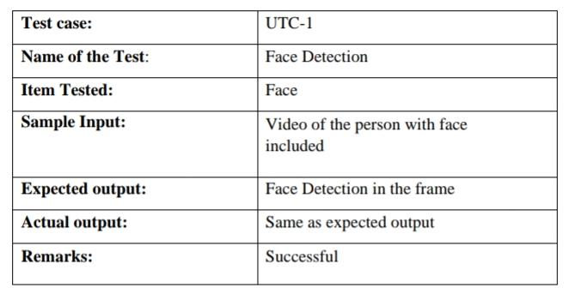

**Functional Testing**

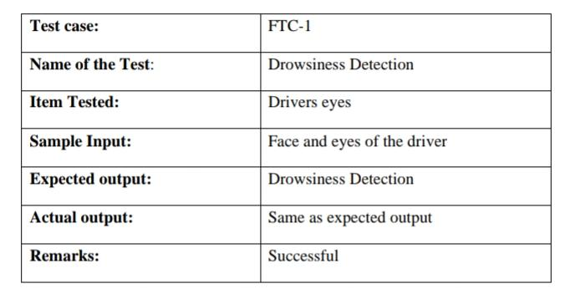

**Integrated Testing**

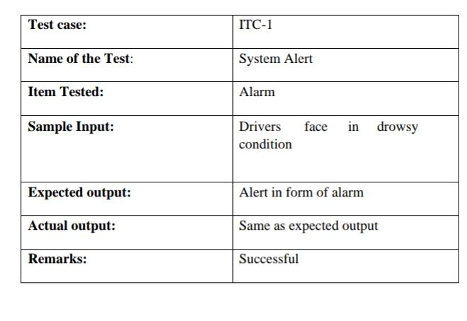

**RESULTS**

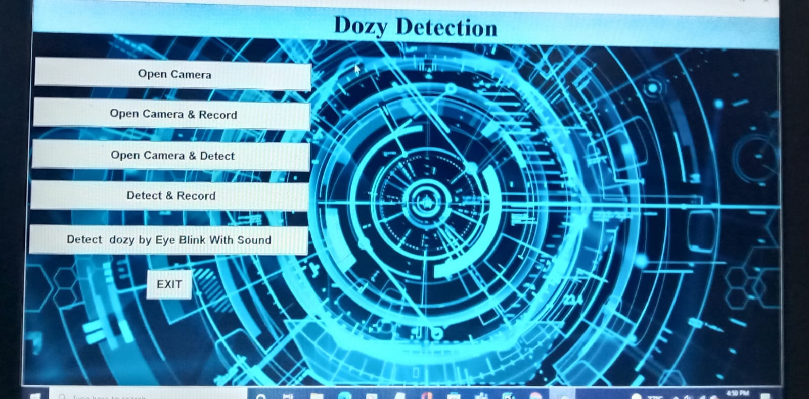

**Non Drowsy Person Face Detection**

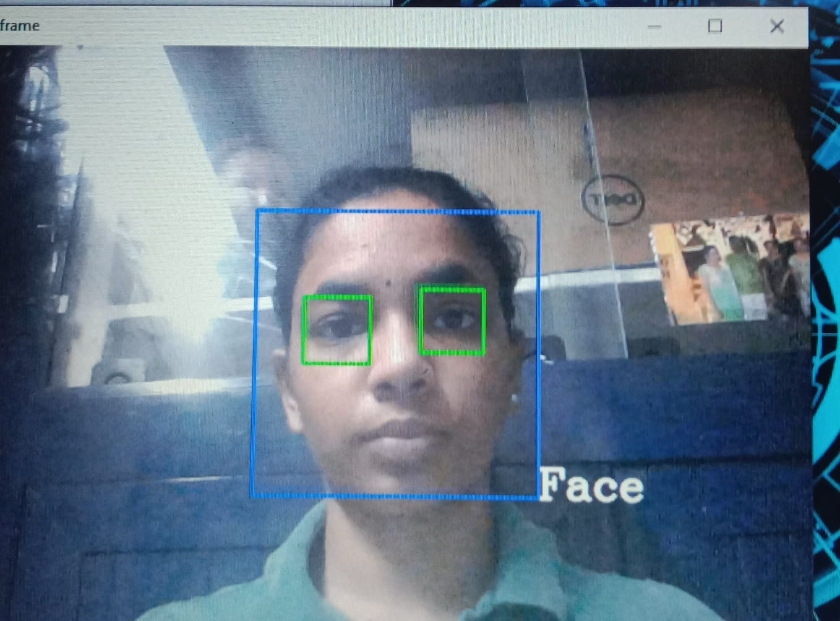

**Drowsy Person Face Detection**

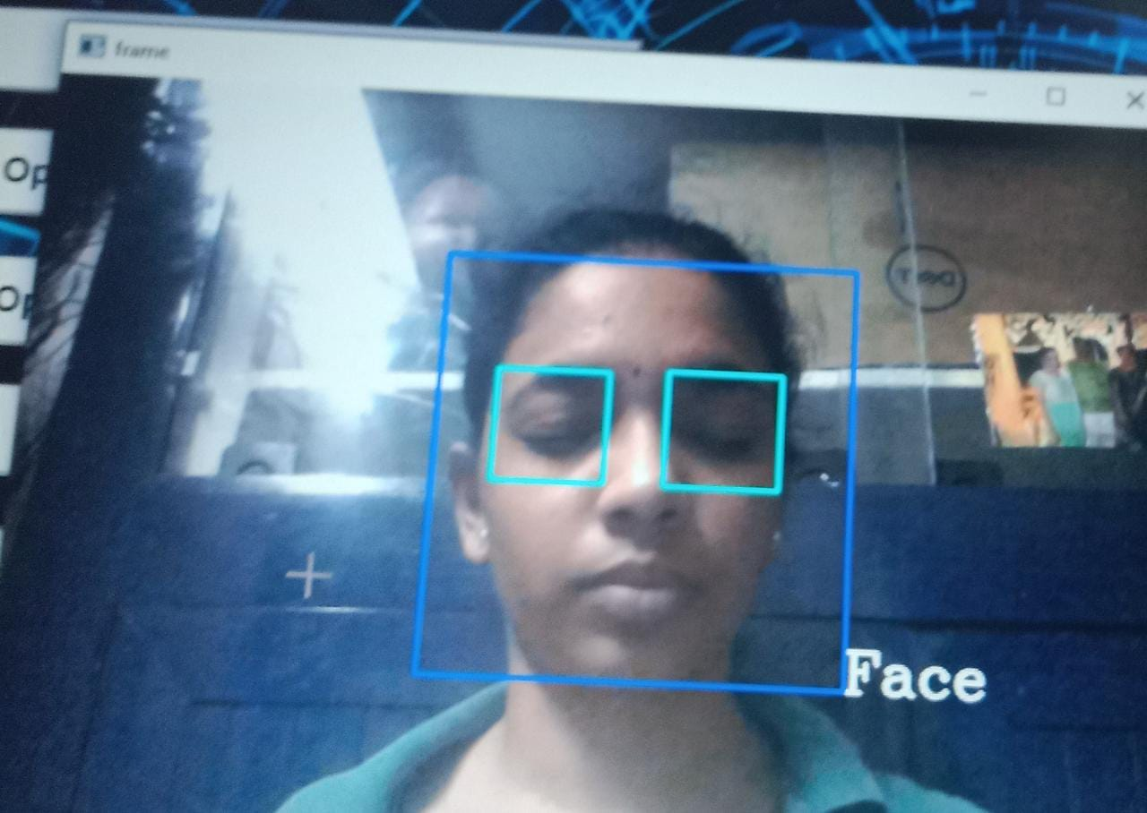

**Recorded video is stored as AVI files**

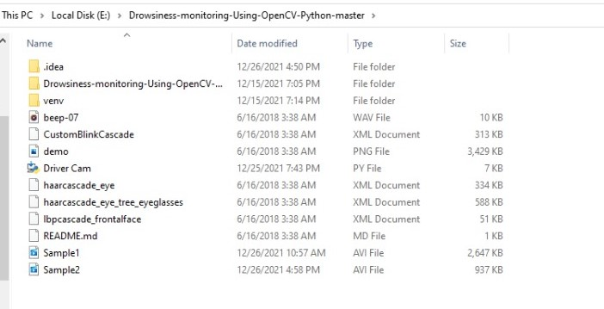

**CONCLUSION**

The current study developed an automated system for detecting drowsiness of the driver. The continuous video stream is read from the system and is used for detecting the drowsiness. It is detected by using haar cascade algorithm. The haar cascade algorithm uses haar features to detect face and eyes. Haar features are predefined are used for detecting different things. The haar features are applied on the image and blink frequency is calculated using perclos algorithm. If the value remains 0 for some amount of time then it detects as sleepy and alerts driver by activating an alarm. If the value remains constant for longer periods then the driver is said to be distracted then also an alarm is activated.

**DISCUSSION AND FUTURE WORK:**

The work can be extended by extracting the features of mouth where the driver can be detected as drowsy through yawning. If the driver yawns repeatedly for more number of times then we can say that he is in sleepy mode. If the number exceeds a limit then we can alert the driver. This work can also be extended by implementing in full night light using IR web cam. It is camera which uses infrared radiations to detect whether the person is drowsy or not.

While this is a research project, there is scope when this completely turns out to be developed into an application which can be run by the end users on their own for their own purposes on their own systems.

**REFERENCES**

* Global Status Report on Road Safety 2015, 2015, [online] Available:

<http://www.who.int/violence_injury_prevention/road_safety_status/2013/en/index.html>.

* Z. Ngcobo, Over 1700 people died on SA roads this festive season, 2017, [online] Available:

[http://ewn.co.za/2017/01/10/over-1-700-people-died-on-sa-roads- this-festive-season](http://ewn.co.za/2017/01/10/over-1-700-people-died-on-sa-roads-this-festive-season)**.**

* <https://www.researchgate.net/publication/336878674_DRIVER_DROWSINESS_DETECTION_SYSTEM>
* Journal of VLSI Signal Processing 23, 497–511 (1999) c °1999. Kluer Acadmic Publishers. Manufactured in The Netherlands. Association for Safe International Road Travel (ASIRT) http://asirt.org/initiatives/informingroadusers/road-safety-facts/road-crash-statistics, 2016
* <https://en.wikipedia.org/wiki/Microslee>
* Journal of VLSI Signal Processing 23, 497–511 (1999) c °1999 Kluer Acadmic Publishers. Manufactured in The Netherlands. [4] [https://docs.opencv.org/trunk/d7/d8b/tutorial_py_face_de tection.html](https://docs.opencv.org/trunk/d7/d8b/tutorial_py_face_de%20tection.html)
* Eye Detection Using Morphological and Color Image Procesing Tanmay Rajpathaka, Ratnesh Kumar and Eric Schwartzb
* A Robust Algorithm for Eye Deteuction on Grey Intensity Face without Spectacles- JCS&T Vol. 5 No. 3
* Froba Kebbuck: Audio- and Video-Based Biometric Person Authentication, 3rd International Conference, AVBPA 2001, Halmstad, Sweden, June 2001. Proceedings, Springer. ISBN 3-540-42216-1.